Everest Base Camp Trek Slide Show
After Hours at the Cross Country Connection, March 14th 6pm

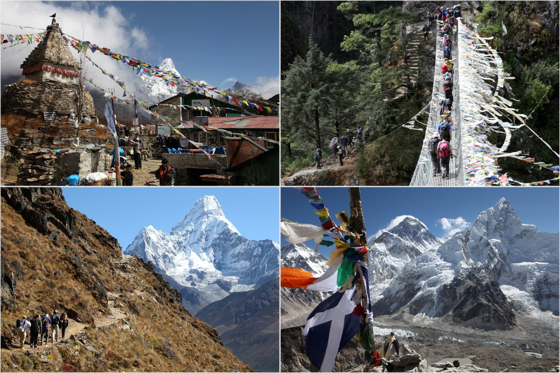

Everest Base Camp Trek: How Far, How Fit, How Much
Slide Show and Discussion

When: Thursday March 14th 6pm
Where: Cross Country Connection, 222 S. 2nd, Laramie WY
Who: Michael Day completed the trek to South Mount Everest Base Camp (elevation 17,598 feet) in October 2012

To see some of Michael’s photos from the trek visit Artisans’ Gallery,
215 South 2nd Street, Laramie WY

