Experience One of Creation’s Most Beautiful Destinations

Kenya, June 16 – July 2, 2017

Day 1 (Friday June 16th ) Safari Park Hotel & Casino

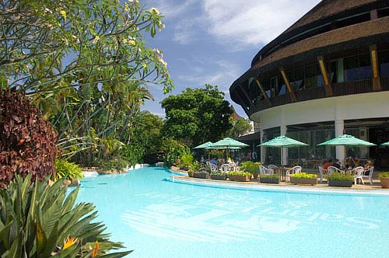
On arrival at Nairobi Jomo Kenyatta International Airport, you will be met and transferred to Safari Park Hotel & Casino booked on bed and breakfast.

Day 2 (Saturday June 17th ) Safari Park Hotel & Casino
After breakfast, welcome and a brief lecture on the History and culture of the people of Kenya by a qualified professor of history and Culture. After the lecture, proceed to Utamaduni Craft Centre- cultural/traditional centre where various cultures are represented in form of artifacts. Lunch break on own account. After lunch proceed to Kazuri beads factory and marvel at the evolution of Kenya’s beautiful jewellery from clay representing various cultures in the country. Dinner on your own. Overnight at Safari Park Hotel & Casino. Bed and breakfast is provided.

Day 3 (Sunday June 18th ) Safari Park Hotel & Casino
After breakfast you will be driven to David Sheldrick Wildlife Trust dedicated to the protection and preservation of Africa’s wilderness and its denizens, particularly endangered species such as elephants and black rhino. Spend time feeding baby elephants and rhinos. Break for lunch at a nearby restaurant (own account). Afternoon return to the hotel and spend the rest of the day enjoying the facilities and beauty of Safari Park Hotel. Dinner own account. Overnight at Safari Park Hotel. Bed and breakfast is provided.

Day 4 (Monday June 19th) Aberdare Country Club

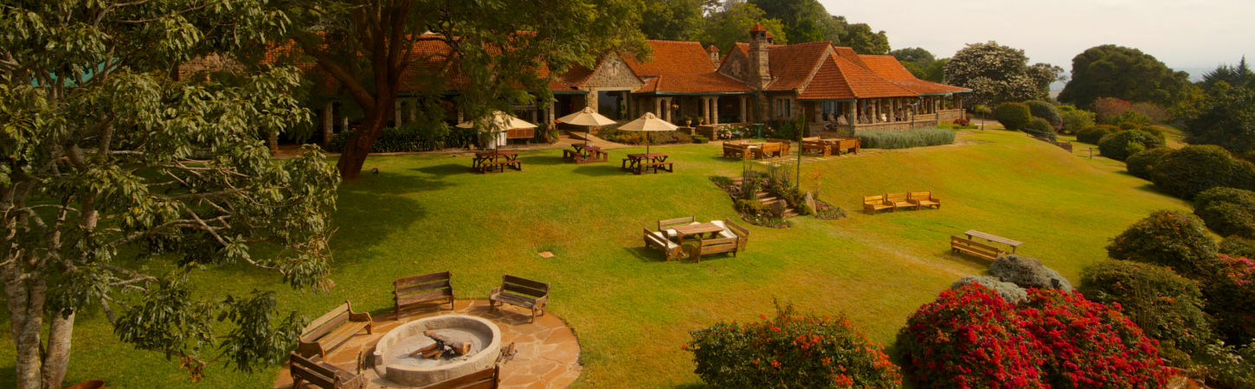

After breakfast, commence your safari with a pleasant drive north to Aberdare region arriving in time for lunch at Aberdare Country Club. After lunch enjoy Kikuyu cultural dance performance. Dinner and overnight at Aberdare Country Club.

Day 5 (Tuesday June 20th) The Ark (Tree Hotel)

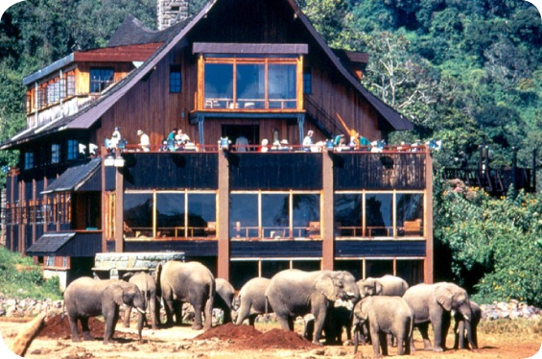

After breakfast proceed for 2 hours interpretive bird walk. Return for lunch. After lunch, you will be transferred to the Tree Hotel (The Ark). After checking in, proceed for a guided nature walk by a resident naturalist. Return to the Ark for the 4 o’clock tea as the resident naturalist gives further lectures on nature and wildlife of the Aberdares. The night is spent comfortably watching the forest game as it comes to drink and lick salt at the floodlit waterhole below, ensuring you many exciting moments. Dinner and overnight at The Ark.

Day 6 - 8 (Wednesday, Thursday & Friday June 21 – 23rd) Sweetwaters Serena luxury Tented Camp
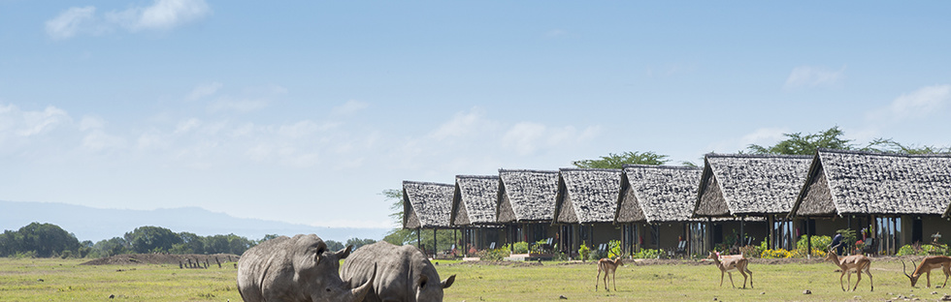

After breakfast drive to Sweetwaters Serena Camp. You will spend three nights in this luxury tented camp Located on the plains of Mount Kenya. The camp features thirty-nine luxury tents, each with its own private veranda overlooking a water hole. The central Rhino Restaurant is housed in the former manager's house of this once colonial farm, and offers both regional and international cuisine. Also within the house is the Kashoggi Bar and lounge, which centers on a blazing log fire. The Waterhole Bar, built in the style of a game-viewing hide, overlooks the waterhole and offers unrivalled wildlife-watching. Host to all the members of the ‘Big Five' (elephant, rhino, lion, buffalo and leopard), the conservancy has a higher wildlife-to-area ratio than any Kenyan national park and is one of only four private game conservancies to have been founded in Kenya. At the forefront of the Kenyan conservancy program, the conservancy boasts the largest black rhino sanctuary in East Africa, hosts the only chimpanzee sanctuary in Kenya, and shelters large numbers of rare and endangered species. Lunch, dinner and overnight at Sweetwater Serena Camp. Sweetwaters Serena Camp lies at the center of the 110,000-acre Ol Pejeta Conservancy, which lies on the Laikipia plains 17 kilometers from Nanyuki and 217 kilometers from Nairobi. One of the Best Luxury Tented Safari Camps in Kenya.

Day 9 & 10 (Saturday & Sunday June 24th & 25th) Serena Mountain Lodge

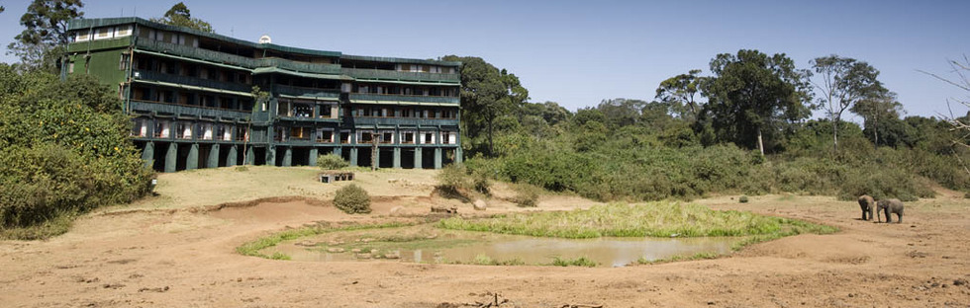

After breakfast, drive to Mt. Kenya National Park for mountain ecology. Arrive in time for lunch at the Serena Mountain Lodge. You will spend two nights in this treetop lodge located at over 6,000 ft. on the slopes on Mount Kenya and surrounded by a dense rainforest that comes alive at dusk with a myriad of sounds. After lunch, proceed for a guided nature walk. After the nature walk, return to the lodge. Enjoy a lecture by the resident naturalist as you enjoy your 4 o’clock tea. Throughout the day and night forest animals visit the lodge’s waterhole and saltlick. This timbered treetop lodge offers champagne-clear mountain air, sweeping views across the tree-canopy, sparkling trout streams, and gentle forest walks. Located at 2,134 meters above sea level, on the lower slopes of the mountain, Mountain lodge is cool, tranquil and hushed for optimum game-sightings. Dinner and overnight at Serena Mountain Lodge.

Day 11 & 12 (Monday & Tuesday June 26th & 27th ) Mburu Gichua Primary School/ Lake Nakuru National Park.

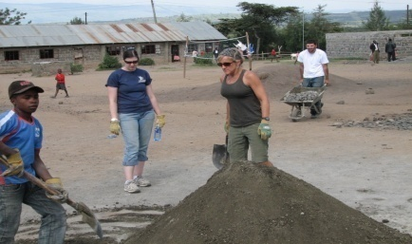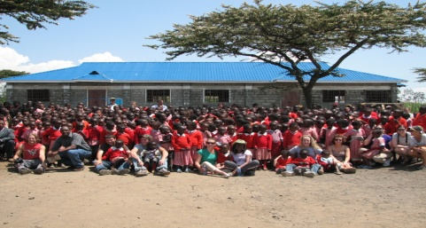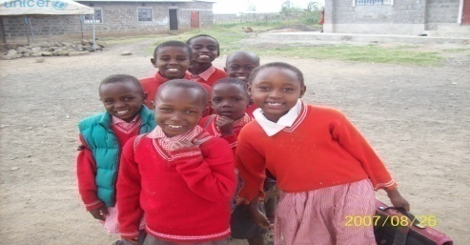

After breakfast, drive south through the escarpment to Nakuru and visit Mburu Gichua Primary School. This school has been identified as a UW-Casper College “sister school.” Thanks to Todd Milken and family for guiding fundraising effort that enabled the 2011 summer program to construct a lunch program that is feeding over 500 children. You will have a chance to see this lunch project while interacting with school children and the local community. Proceed to Lake Nakuru National Park arriving at Lake Nakuru Lodge for late lunch. After lunch proceed for a game drive. Return to the Lake Nakuru Lodge for dinner and overnight.

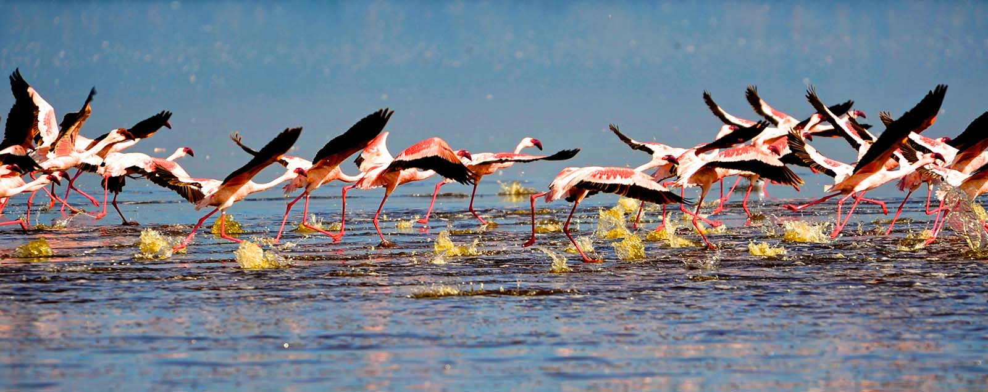

After breakfast take a morning and afternoon game drive. Lake Nakuru National Park has earned its fame as the home of the greatest bird spectacle in the world. The abundance of lions, leopards, buffaloes, and other Savannah and forest game makes game viewing a lifetime adventure. While enjoying lunch at Lake Nakuru Lodge, listen to a lecture by Lake Nakuru’senviromenatlist, John Kuria). Lunch, dinner and overnight at Lake Nakuru Lodge. Lake Nakuru Lodge lies in the heart of this grand park. It blends well with its surroundings and the animals often browse peacefully close by, much to the delight of most lodge visitors. There are accommodations for 120 people, either in family rooms, cottages, or suites. Given the rather close proximity of the park to Nairobi, and its marvelous setting (you can see the lake from the grounds), the lodge is very popular for weekend (as well as week day) travelers. Lake Nakuru National Park is generally home to one of the greatest bird spectacles in the world – a myriad of more than a million pink (Lesser) flamingos seasonally use its waters to feed on the abundant algae that thrive in its warm water wetlands. This gem of a national park has a great deal more to offer than its magnificent bird life. Here you’ll also find lions, leopards, buffaloes, and other savannah and forest game which make game viewing worthwhile.

Day 13-15 (Wednesday, Thursday & Friday June 28-30^{th)} Mara Serena Safari Lodge

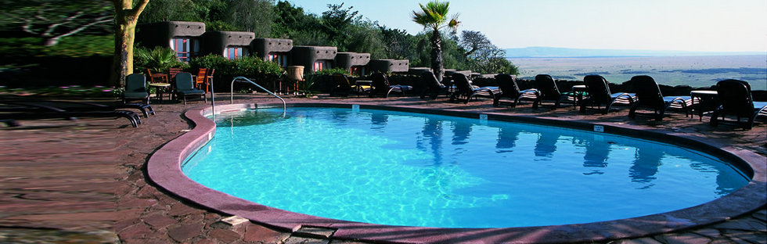

After breakfast, travel to Maasai Mara from Lake Nakuru. Though this is a long drive (approximately 160 miles to the east entrance of the Maasai Mara National Reserve, 5 hours or so) it is also a real treat. First, we’ll cross the floor of the Great Rift Valley, then, as we enter the park, it’s quite likely we’ll visit a Maasai boma. Once in the park, you’ll quickly realize why the Mara is such a special place. You will spend 3 nights in this natural paradise. You’ll likely encounter the grandest diversity of wildlife you’ve ever experienced: lions, cheetahs, hyenas, jackals, buffalos, giraffes, elephants, zebras, baboons, vervet monkeys, ten different antelope species (eland, waterbuck, wildebeest, topi, hartebeest, impala, Grant’s gazelle, Thomson’s gazelle, oribi, and dik-dik), hippopotamuses, crocodiles, warthogs, mongooses, hyraxes, lizards and perhaps even snakes. Then there is a multitude of bird species from the massive ostrich to the little lovebird, from the elegant grey crown crane to the fascinating secretary bird, from the ever-watchful eagles to all the different vultures, from the ugly marabou stork to the colorful lilac-breasted roller, and so many more. Each day both morning and afternoon game drives are scheduled. Breakfast, lunch & dinner at Mara Serena Safari Lodge. The lodge is located within the famous Maasai Triangle of the Maasai Mara National Reserve, the ultimate safari destination. Set high on a bush-cloaked hill with long views over the savannah and down to the winding coils of the hippo-filled Mara River, it stands center-stage to one of Africa's most dramatic wildlife arenas, with a ringside seat for the ‘greatest wildlife show on earth', the legendary migration of the wildebeest (we may see some of the first migrants enter the Maasai Mara). Styled to echo the circular motif of a traditional Maasai manyatta, Maasai Mara Serena lodge blends international sophistication with raw African beauty, while featuring twin rows of individual rooms, each with its own view of the famous Mara River. The central bar and dining areas enjoy spectacular views, as does the rock-surround swimming pool. Each uniquely-presented room is accommodated in its own stand-alone modular unit, with uninterrupted views, private balcony and spacious seating area.

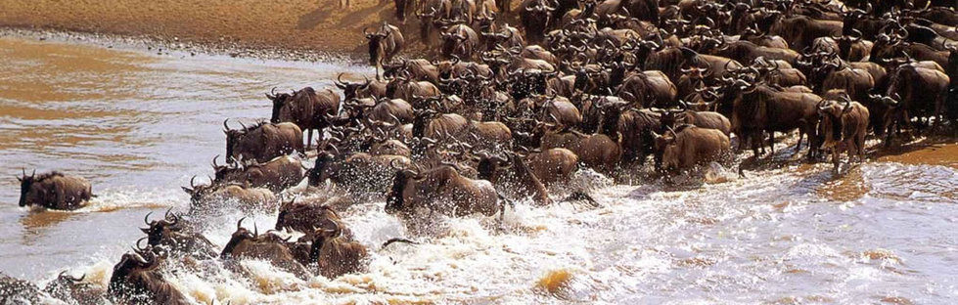

World renowned for the breathtaking spectacle of ‘the greatest wildlife show on earth', the awe inspiring annual migration of the wildebeest, the Mara is Kenya's most visited protected area. Technically an extension of Tanzania's renowned Serengeti National Park, the Mara constitutes only 4% of the entire Serengeti ecosystem but its rolling grasslands, meandering rivers and towering escarpments offer one of the world's most rewarding and evocative wildlife arenas.

Day 16 (Saturday July 1st ) Lake Naivasha Sopa Lodge

After breakfast, drive across the floor of the great rift valley to Lake Naivasha. Lake Naivasha is one of the gems in a necklace of Rift Valley Lakes. The Lake is famous for its remarkable variety of bird life and its hippo colonies. Dinner and overnight at Lake Naivasha Sopa Lodge
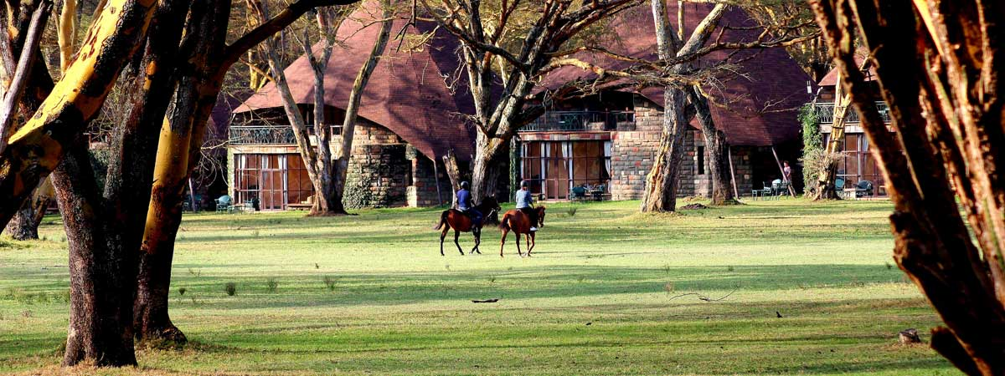
Day 17 (Sunday July 2nd ) Nairobi and Departure
After breakfast, check out and depart for Nairobi and transfer to Jomo Kenyatta Airport for your outbound flight back home. Lunch and dinner own account

